Name:
Social Sciences

Part 1
Complete the reading provided and Create a chart like this in your notebook (you do not have to fill in this chart here, it is more important to have in your notes!)
Type of Social Scientist | What do they do? | What questions do they ask? | Draw/create an illustration of what they do
Archaeologists

Historians

Geographers

After completing the reading and chart in your notes, answer the following question below. This will be graded- be sure to use strong details and complete sentences!

How are social scientists like detectives? Explain.

Part 2
Using the image below, complete the chart as if you were each of the social scientists.
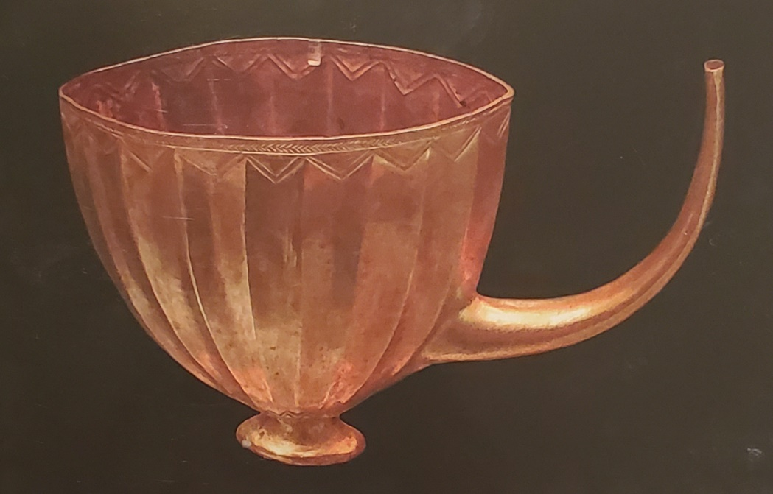

Type of Social Scientist | Questions they would ask | Why they would ask it | Possible answers to your questions
Archaeologist
Historian
Geographer

After completing the chart, create a hypothesis of what you believe the object is/was used for. Be specific and use complete sentences.

